Data Mining Assignment 4

1) Read Chapter 4 (all sections) and Chapter 5 (Sections 5.2, 5.5, 5.6 and 5.7).  
  
2) Consider the following data set for a binary class problem.

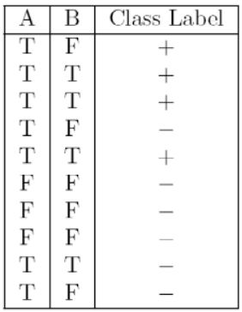

Repeat In Class Exercise #38 using the misclassification error rate instead of information gain to determine the best split. Which of these splits considered is the best according to misclassification error rate?

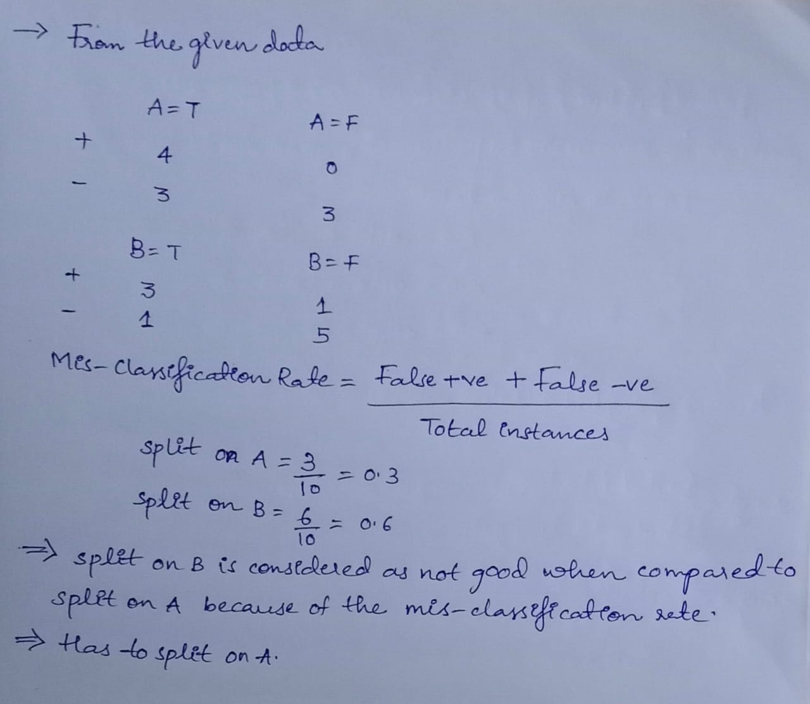

3) Consider the training examples shown below for a binary classification problem.

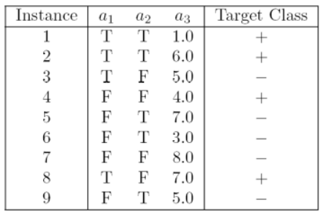

Repeat In Class Exercise #39 using the misclassification error rate instead of information gain to determine the best split. Which of these splits considered is the best according to misclassification error rate?

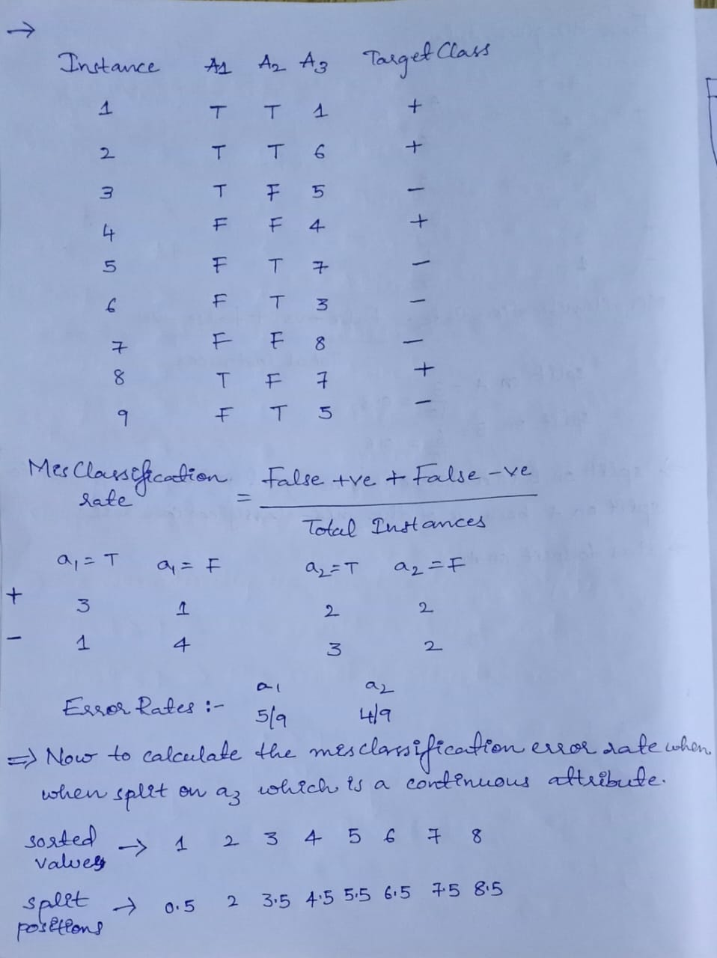

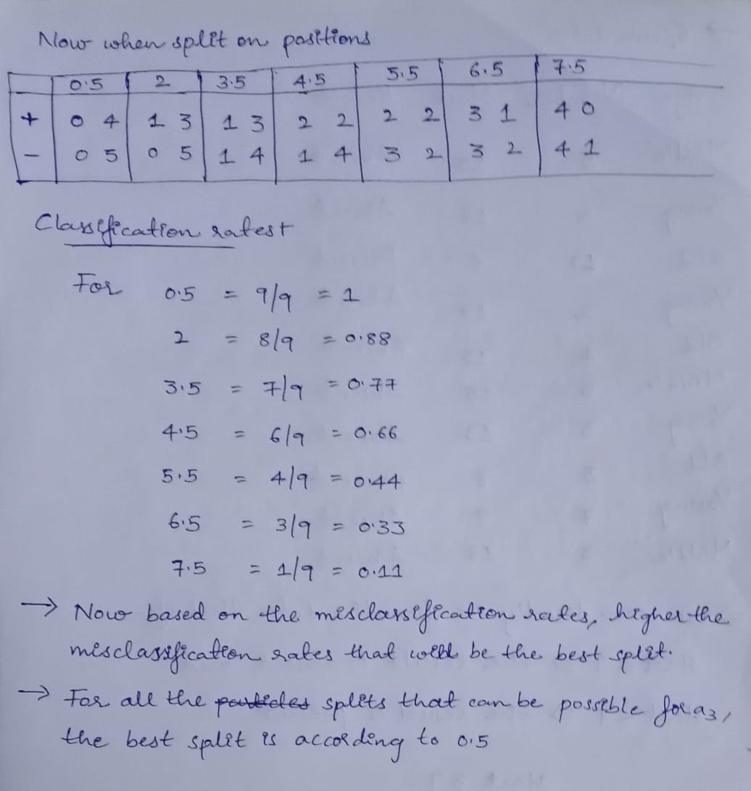  
  
4) The file <http://www-stat.wharton.upenn.edu/~dmease/rpart_text_example.txt> gives an example of text output for a tree fit using the rpart() function in R from the library rpart. Use this tree to predict the class labels for the 10 observations in the test data <http://www-stat.wharton.upenn.edu/~dmease/test_data.csv> linked here. Do this manually - do not use R or any software.  
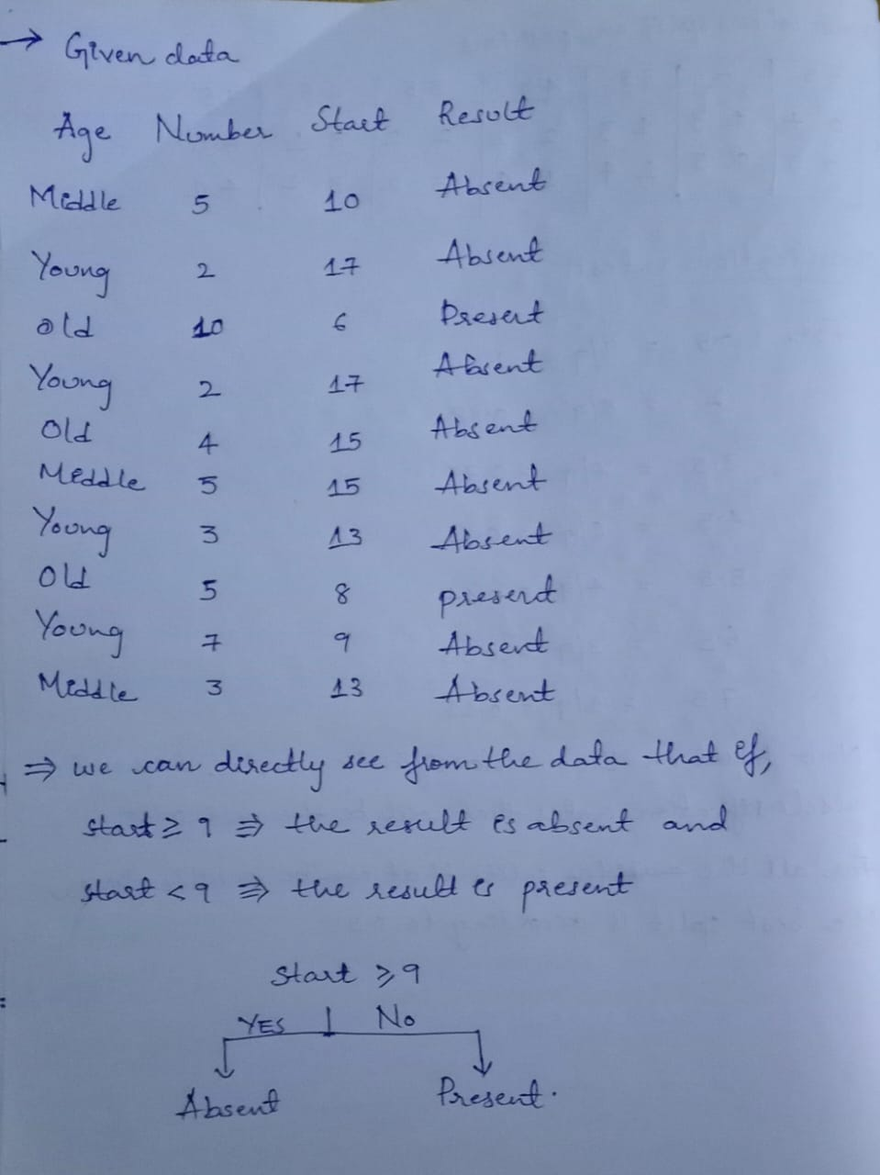

5) I split the popular sonar data set into a training set (<http://www-stat.wharton.upenn.edu/~dmease/sonar_train.csv>) and a test set (<http://www-stat.wharton.upenn.edu/~dmease/sonar_test.csv>). Use R to compute the misclassification error rate on the test set when training on the training set for a tree of depth 5 using all the default values except control=rpart.control(minsplit=0,minbucket=0,cp=-1, maxcompete=0, maxsurrogate=0, usesurrogate=0, xval=0,maxdepth=5). Remember that the 61st column is the response and the other 60 columns are the predictors.   
  
6) Do Chapter 5 textbook problem #17 (parts a and c only) on pages 322-323. Note that there is a typo in part c - it should read "Repeat the analysis for part (b)". We will do part b in class.

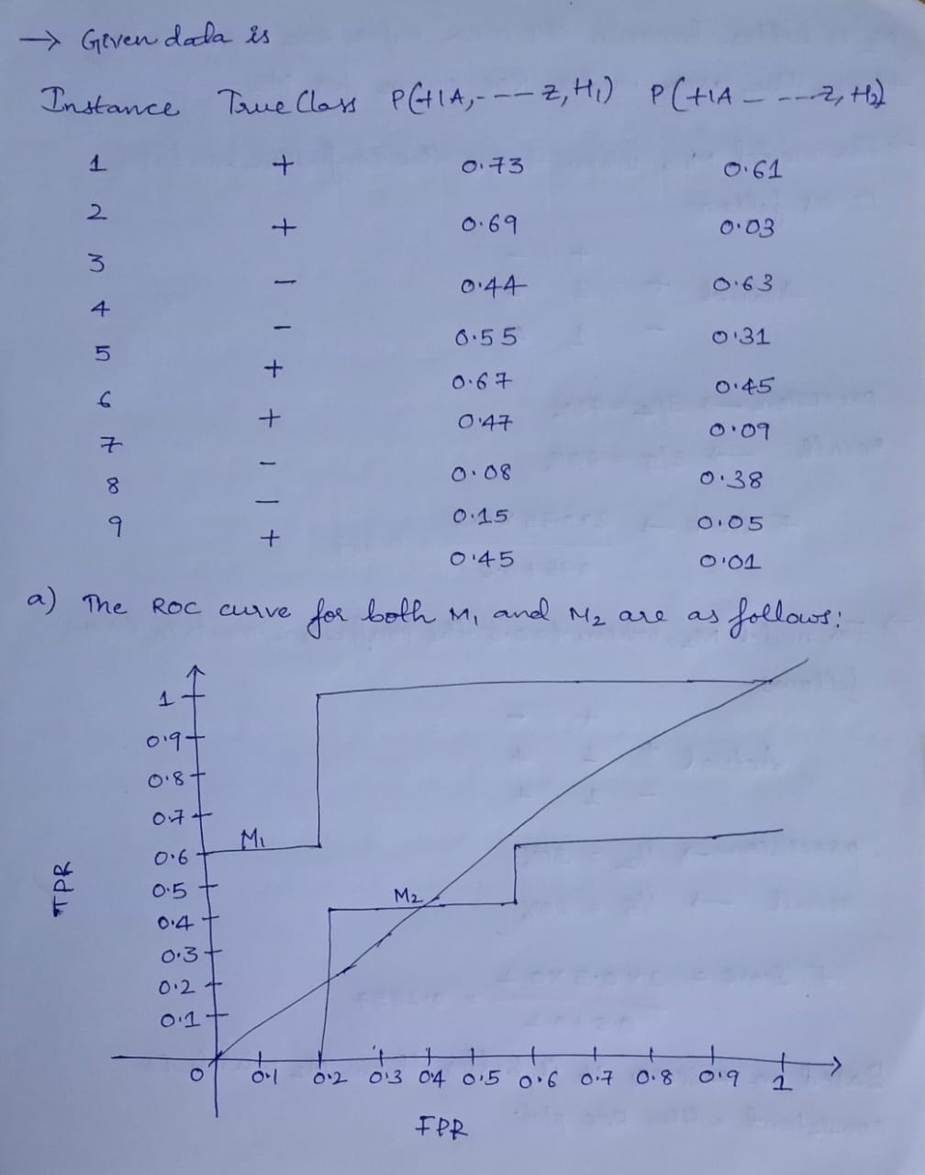

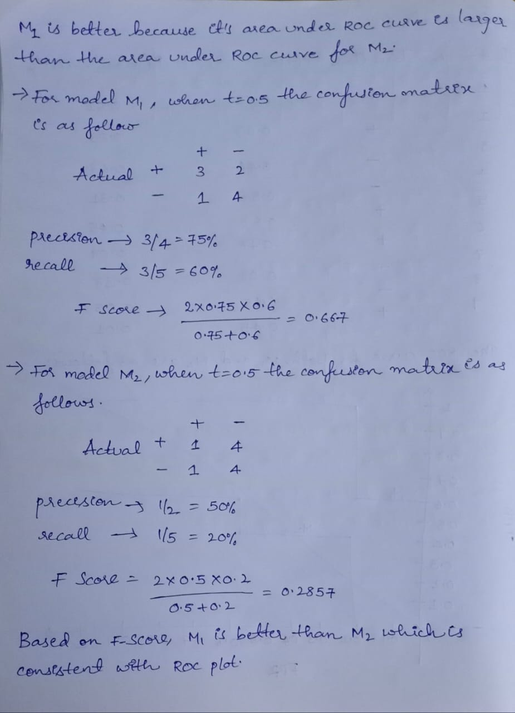  
  
7) Compute the misclassification error on the training data for the Random Forest classifier from In Class Exercise #47. Show your R code for doing this.  
  
8) This question deals with In Class Exercise #42.  
  
a) Repeat In Class Exercise #42 for the k-nearest neighbor classifier for k=5 and k=6.  
  
b) Repeat part a using the exact same R code a few times. Explain why both the training errors and the test errors often change for k=6 but not for k=5. Hint: Read the help on the knn function if you do not know.